Exception Handling in Java->

The **exception handling in java** is one of the powerful *mechanism to handle the runtime errors* so that normal flow of the application can be maintained.

### **What is exception**

**Dictionary Meaning:** Exception is an abnormal condition.

In java, exception is an event that disrupts the normal flow of the program. It is an object which is thrown at runtime.

### **What is exception handling**

Exception Handling is a mechanism to handle runtime errors such as ClassNotFound, IO, SQL, Remote etc.

### **Advantage of Exception Handling**

The core advantage of exception handling is **to maintain the normal flow of the application**. Exception normally disrupts the normal flow of the application that is why we use exception handling. Let's take a scenario:

1. statement 1;
2. statement 2;
3. statement 3;
4. statement 4;
5. statement 5;//exception occurs
6. statement 6;
7. statement 7;
8. statement 8;
9. statement 9;
10. statement 10;

in this 1-4 will execute but from 6-10 will not execute just because exception occurs in 6 so for handling this we use exception handling.

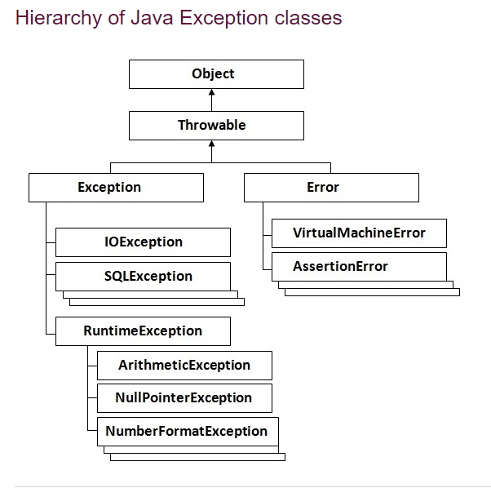

### **Types of Exception**

There are mainly two types of exceptions: checked and unchecked where error is considered as unchecked exception. The sun microsystem says there are three types of exceptions:

1. Checked Exception
2. Unchecked Exception
3. Error

## **Difference between checked and unchecked exceptions**

1. Checked->The classes that extend Throwable class except RuntimeException and Error are known as checked exceptions e.g.IOException, SQLException etc. Checked exceptions are checked at compile-time.

If

A a =new A();

And now

a=NULL

and if we call any method then error will show .

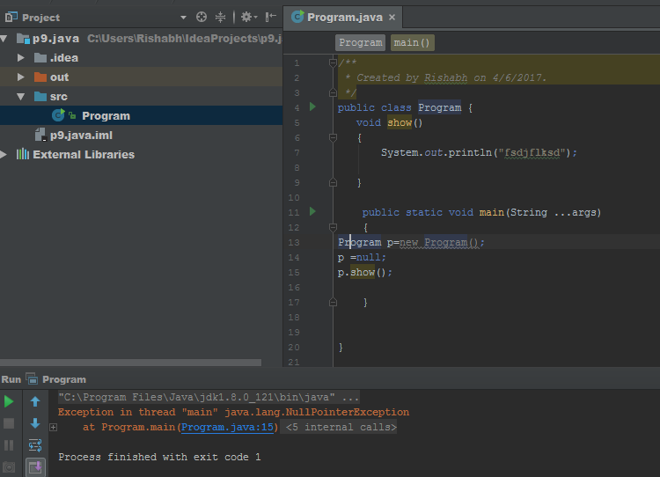

2.unchecked exeption->

The classes that extend RuntimeException are known as unchecked exceptions e.g. ArithmeticException, NullPointerException, ArrayIndexOutOfBoundsException etc. Unchecked exceptions are not checked at compile-time rather they are checked at runtime.

### **3) Error**

Error is irrecoverable e.g. OutOfMemoryError, VirtualMachineError, AssertionError etc.

### **Common scenarios where exceptions may occur**

There are given some scenarios where unchecked exceptions can occur. They are as follows:

### **Scenario where ArithmeticException occurs->**

### 

### **2).Scenario where NullPointerException occurs->**

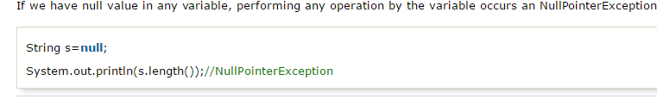

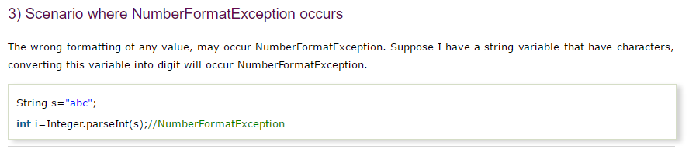

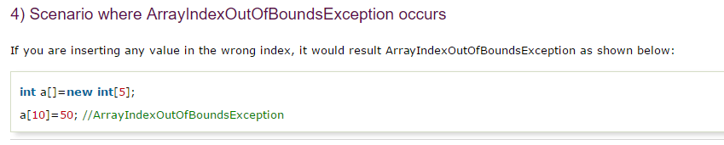

## **Java Exception Handling Keywords->**

There are 5 keywords used in java exception handling.

1. try
2. catch
3. finally
4. throw
5. throws